​Experiment: Bottom-Up Evaluation of S-Attributed​
​Syntax-Directed Definition Using C​
​1. AIM​
​To write and execute a C program to perform bottom-up evaluation of an S-attributed​​syntax-directed definition and display the final evaluated value.​
​2. ALGORITHM​
​1.​ ​Start the program.​
​2.​ ​Read the arithmetic expression from the user.​​3.​ ​Identify the numbers and addition operator.​
​4.​ ​Apply the grammar rules​​T → num​​and​​E → T​​.​​5.​ ​Evaluate​​E → E + T​​using bottom-up evaluation.​​6.​ ​Calculate the semantic attributes.​
​7.​ ​Display the final value of E.​
​8.​ ​Stop the program.​
​3. PSEUDOCODE​
​None​
​START​
​Read arithmetic expression​
​Read first number​
​Assign value to T​
​Assign T value to E​
​Read addition operator​
​Read second number​
​Calculate E = E + T​
​Display value of E​
​STOP​
​4. C PROGRAM​
​None​
​#include <stdio.h>​
​int main()​
​{​
​int num1, num2, E, T;​

​char op;​
​printf("Enter arithmetic expression: ");​​scanf("%d %c %d", &num1, &op, &num2);​
​if (op == '+')​
​{​
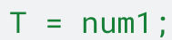​T = num1;​
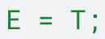​E = T;​
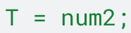​T = num2;​
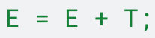​E = E + T;​
​printf("Value of E = %d\n", E);​​}​
​else​
​{​
​printf("Invalid operator!\n");​​}​
​return 0;​
​}​
​5. SAMPLE INPUT​
​C/C++​
​Enter arithmetic expression:​​3​​+​​5​
​6. SAMPLE OUTPUT​
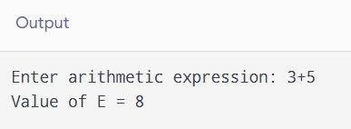

​7.RESULT:​
​Thus, the C program was successfully executed to perform bottom-up evaluation of an​​S-attributed syntax-directed definition and display the final value as 8.​

